

**MIDDLE EAST TECHNICAL UNIVERSITY**

**DEPARTMENT OF ELECTRICAL & ELECTRONICS ENGINEERING**

**E463 – PROJECT #3**

**Nevzat Safa Şenyayla (2263796)**

**Etki Açılan (2165694)**

**5.1.2019**

CONTENT

INTRODUCTION 3

1. 3 PHASE THYRISTOR CONVERTER 3

2. BUCK CONVERTER 5

Component Selection 5

Inductor Selection 5

Capacitor Selection 6

MOSFET Selection 6

Diode Selection 7

Simulation Results 8

Efficiency 11

Cost Analysis 11

Comments 11

3. BOOST CONVERTER (Webench) 12

CONCLUSION 16

REFERENCES 16

# INTRODUCTION

This project is the 3rd project of EE463 course. It includes simulations of PM motor drive with three phase thyristors and PI controller, buck converter design and finally boost converter design on Webench. The simulations are done in MATLAB/Simulink environment and Webench.

# 3 PHASE THYRISTOR CONVERTER

Figure 1 shows the Simulink model which has a PI controller as speed controller.

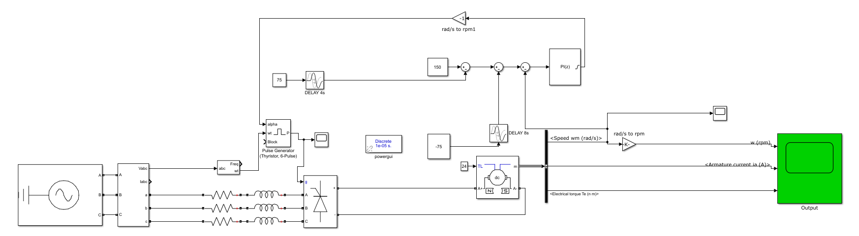

Figure 1 Simulink Model

Figure 3 shows the speed, armature current and electrical torque of the motor with the PI controller in Figure 2.

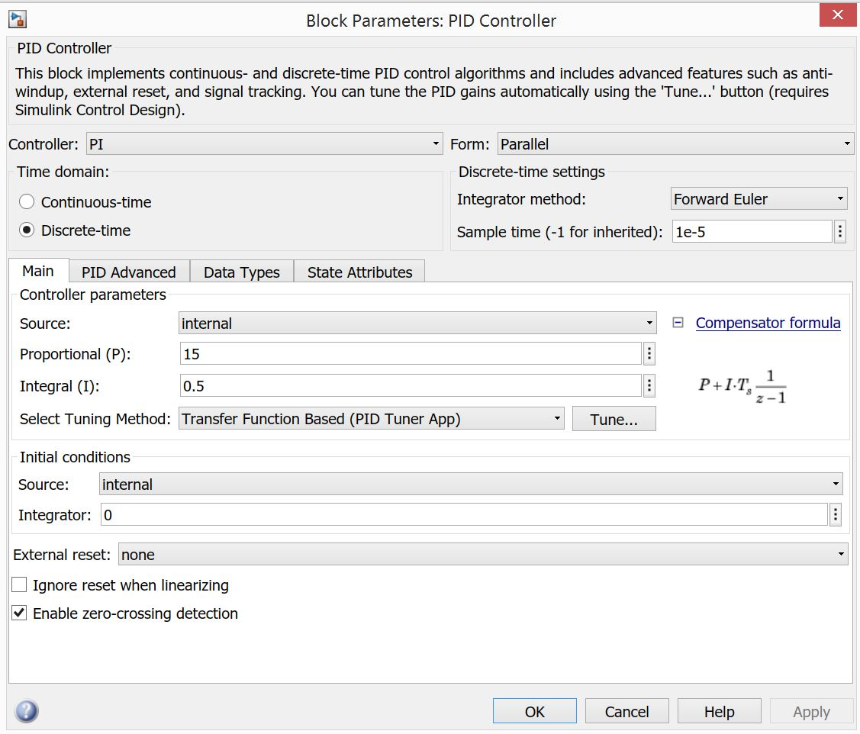

Figure 2 PI controller

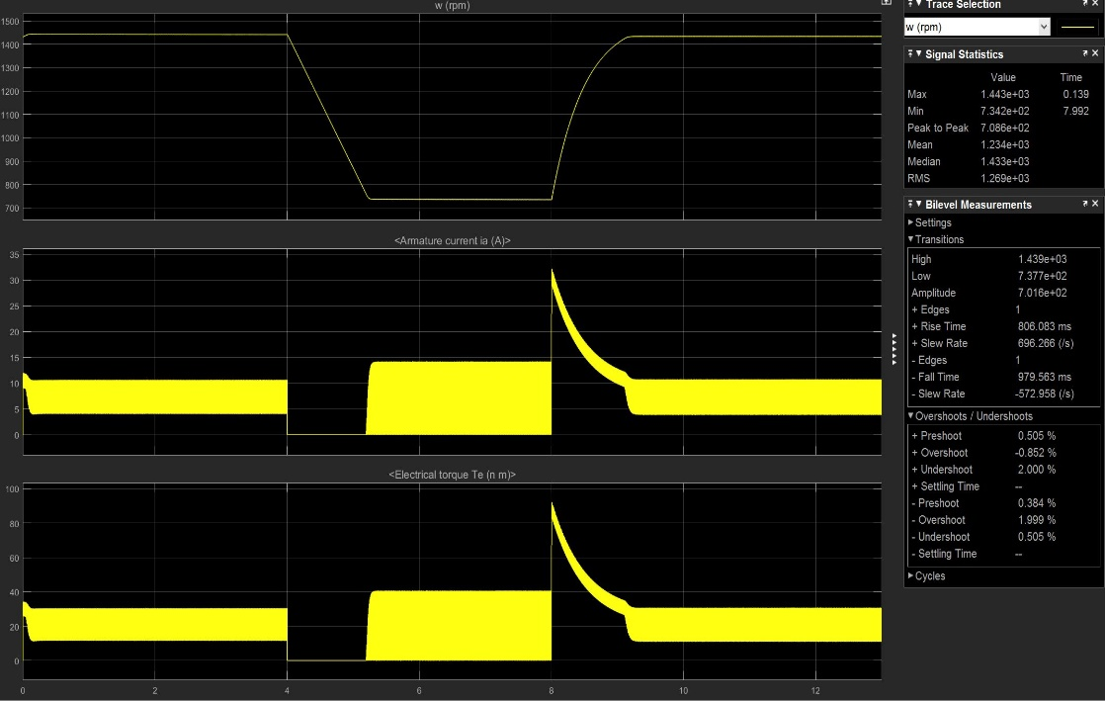

Figure 3 Speed, Armature Current and Output Torque of the Motor

As can be seen from Figure 1, PI controller takes 150rad/s as reference. When there is a difference between the reference and the actual motor speed, the difference is reflected to PI controller. Then, the output of the controller goes into pulse generator as an input which determines the firing angle. General idea is that if the error is high and motor should slow down, the firing angle is high which makes the output voltage decrese. As a result, the speed decreases. As a matter of fact, armature current is zero at which the reference point changes to 75 rad/s until the motor slows down and its speed is equal to the reference again. When the reference speed is 150 rad/s again, the armature current increases sharply to accelerate the motor again as it is shown in Figure 2.

Moreover, as it can be seen from Figure 2, as in the case of constant flux, the torque is linearly proportional to the armature current.

PI controller can be changed to obtain different response characeristics. Different observations are made and uploaded to GitHub.

Figure 4 shows two different Kp valued PI controlled motor outputs.

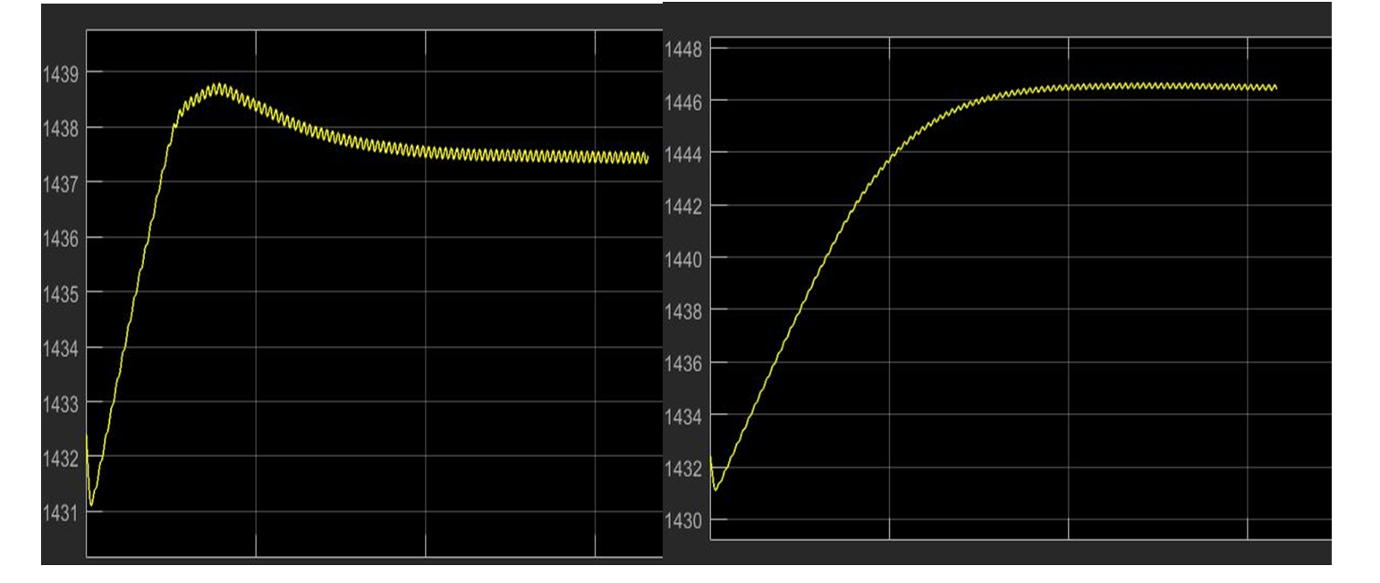

Figure 4 Two different Kp values of PI values motor output

The left one has P = 30 and the right one has P = 10 as Kp values. As can be seen, for greater Kp, the overshoot is higher. However, at the lower Kp one the steady-state error decreases since the output speed value is closer to 150*30/π than the right one. Ki also has the same effect.

# BUCK CONVERTER

Figure 5 shows the Simulink model of buck converter with open loop.

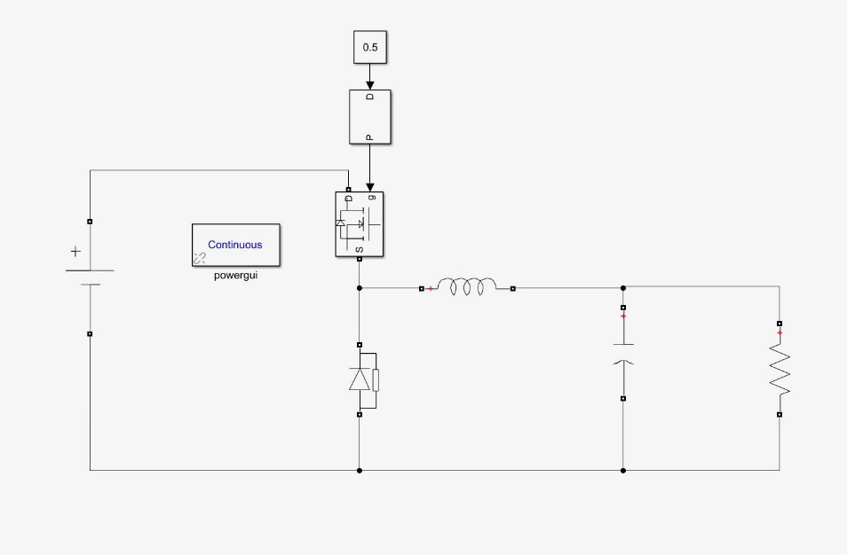

Figure 5 Simulink model without PI

The Input voltage is 56V and desired output voltage is 28 V. The duty cycle is calculated in Equation 1.

(1)

## Component Selection

### Inductor Selection

The filter inductor value and its peak current are determined based on the desired maximum inductor ripple current. The equation used for inductor selection is shown in Equation 2.

(2)

The switching frequency is selected as 10 kHz which is a reasonable value considering the commercial switching equipment. Also, the ripple of the inductor is desired as 50mA. Then, the inductance value is calculated in Equation 3.

(3)

For the desired ripple current, an inductor with the value of 28mH is needed. For ease of selection, an inductor of 30mH is chosen from mouser.com. The product code of inductor is B82791H2301N001. The considerations while selecting are listed below.

* The inductance
* DC Current carrying capacity
* Resistance

The selected inductor fulfills the first two requirements. The resistance of it is greater than its peers, however, considering the price, DTSN33/15/8 is a suitable selection. Its values are listed in Table 1.

Table 1: Inductor characteristics

|  |  |  |  |  |  |
| --- | --- | --- | --- | --- | --- |
| **part No.** | **Inductance mH** | **D.C. Current** | **Resistance** | **Insulation** | **Weight** |
| **(Millihenries)** | **(Amps)** | **(Ohms)** | **Class** | **(lbs.)** |
| DTSN33/15/8 | 15 | 8 | 0.046 | - | - |

Two inductors will be connected series to achieve 30 mH.

The new ripple current with 30mH is calculated in Equation 4. ( Simulated in Figure 6)

A (4)

### Capacitor Selection

The considerations while selecting the capacitor was the rated voltage, ripple current and corner frequency of the LC filter. To meet this considerations, a 330uH capacitor is selected from mouser.com which is 860010675019 coded. Its characteristics are shown in Table 2.

Table 2: Capacitor properties

|  |  |
| --- | --- |
| Capacitance: | 330 uF |
| Voltage Rating DC: | 50 VDC |
| Ripple Current: | 649 mA |

The corner frequency of the LC filter is calculated in Equation 5.

(5)

This corner frequency helps eliminating AC components and passing DC components.

After using these capacitors and inductors, a PI controller is added to the simulink model in order to keep the voltage close to 28V which is the desired value. It is shown in Figure 4.

### MOSFET Selection

The most important considerations when selecting a MOSFET is the continous current rating and the voltage rating. For this purpose the voltage rating must exceed 56V and the current rating must exceed 8.5A since the maximum current is measured as 8.5A at the inductor. Also, the delay times should be smaller. For this purpose, from mouser.com NVD3055L170T4G-VF01 coded MOSFET is selected. Its properties can be seen in Figure 6. The selection relies on Figure 11 and 12.

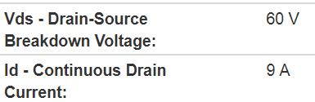

Figure 6 MOSFET Vds and Id ratings

### Diode Selection

To reduce the losses of the diode, the sschottky diodes are considered in this design. Even though they are more expensive, their switching time and response are better than the standard diodes. Moreover, the diode also has to handle the power dissipation. Therefore, V4PAN50-M3/I is selected from mouser.com which has the characteristics as listed in Table 2. The selections rely on Figure 9 and 10.

TABLE 2: Diode characteristics

|  |  |
| --- | --- |
| If - Forward Current: | 4 A |
|  |  |
| Vrrm - Repetitive Reverse Voltage: | 50 V |
|  |  |
| Vf - Forward Voltage: | 0.5 V |
|  |  |
| Ifsm - Forward Surge Current: | 80 A |
|  |  |
| Pd - Power Dissipation: | - |

The updated simulink model with PI control is shown in Figure 7.

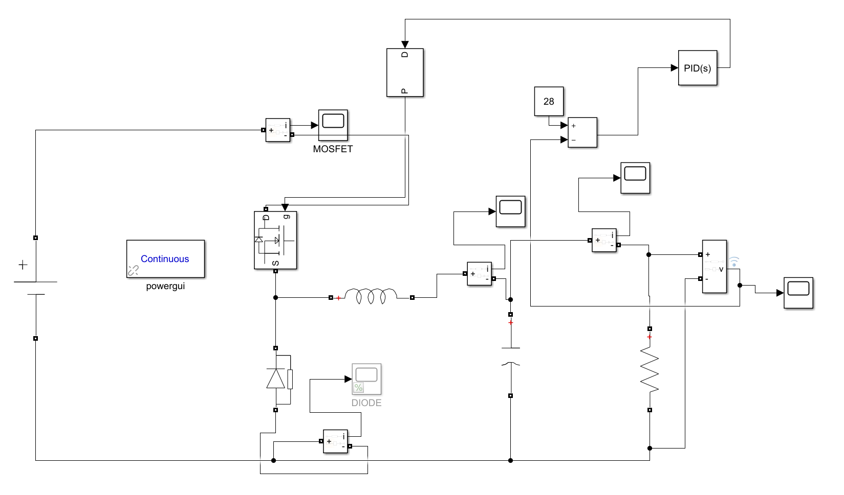

Figure 7 Buck Converter with PI controller

## Simulation Results

Figure 8 shows output voltage ripple. It is measured as 1.745mV.

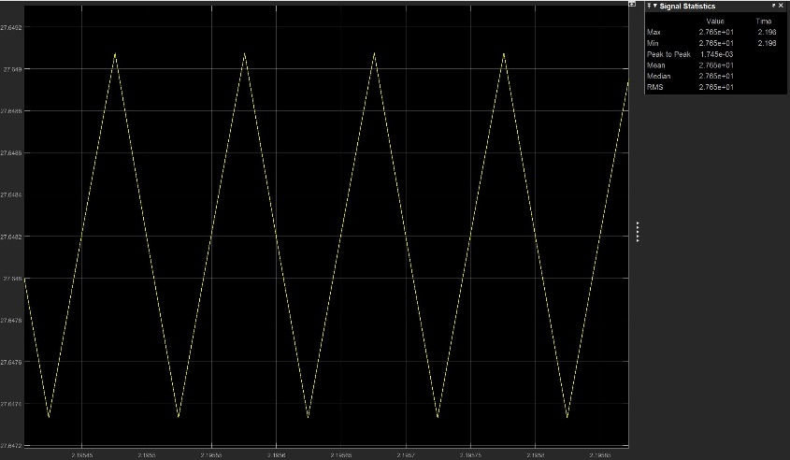

Figure 8 Output Voltage Ripple

Figure 9 shows inductor current ripple. It is measured as 0.04608A. Note that this value is calculated in Equation 4.

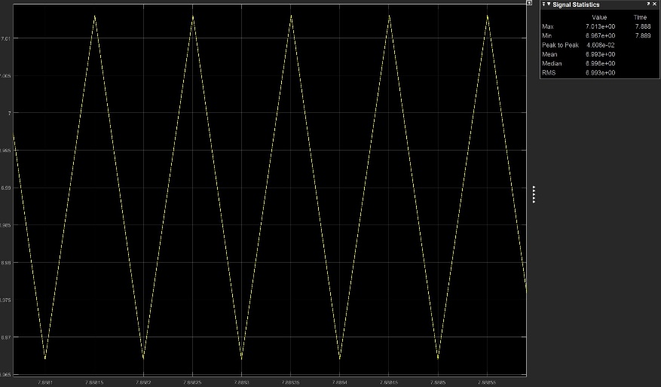

Figure 9 Inductor current ripple

Figure 10 shows the steady state graph of the output voltage of the converter.

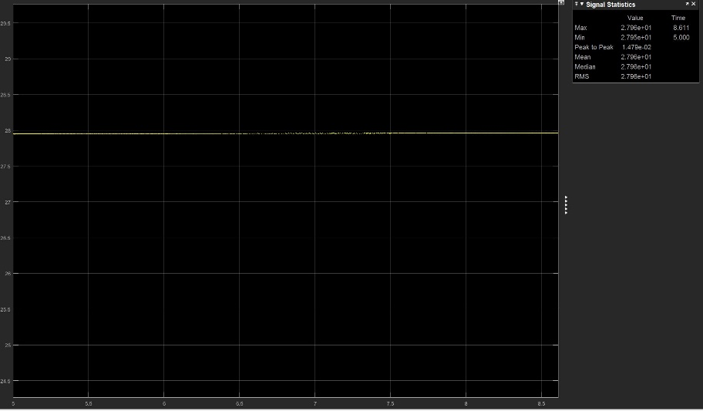

Figure 10 Output Voltage of the converter

Figure 11 shows the steady state graph of the output current of the converter.

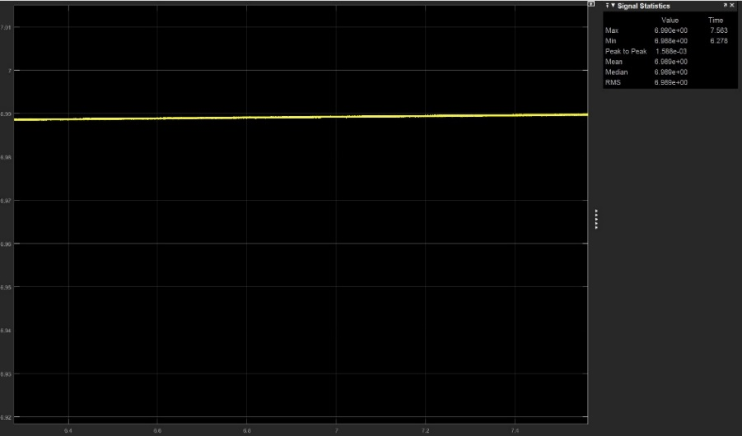

Figure 11 Output Current of the converter

Figure 12 shows the surge current of diode.

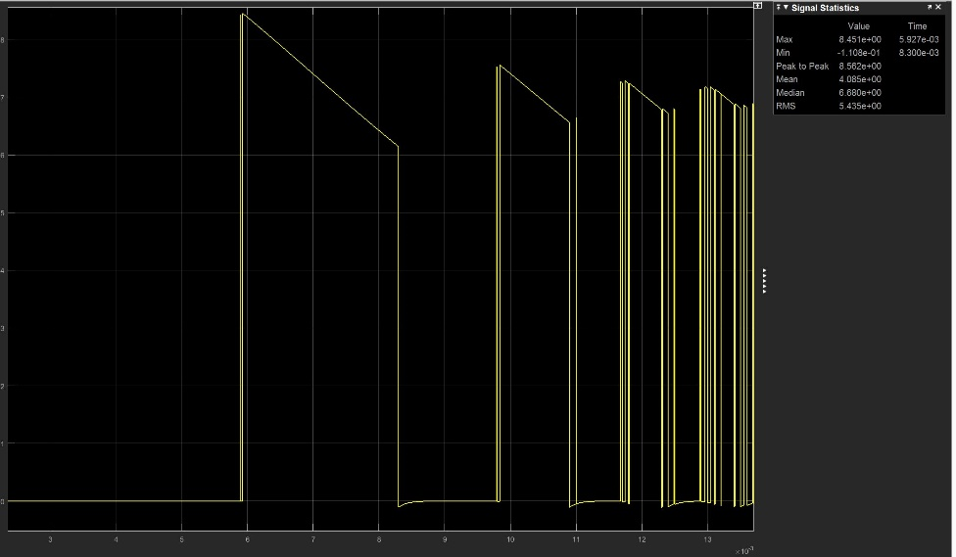

Figure 12 Surge current of diode

Figure 13 shows the steady state current of diode.

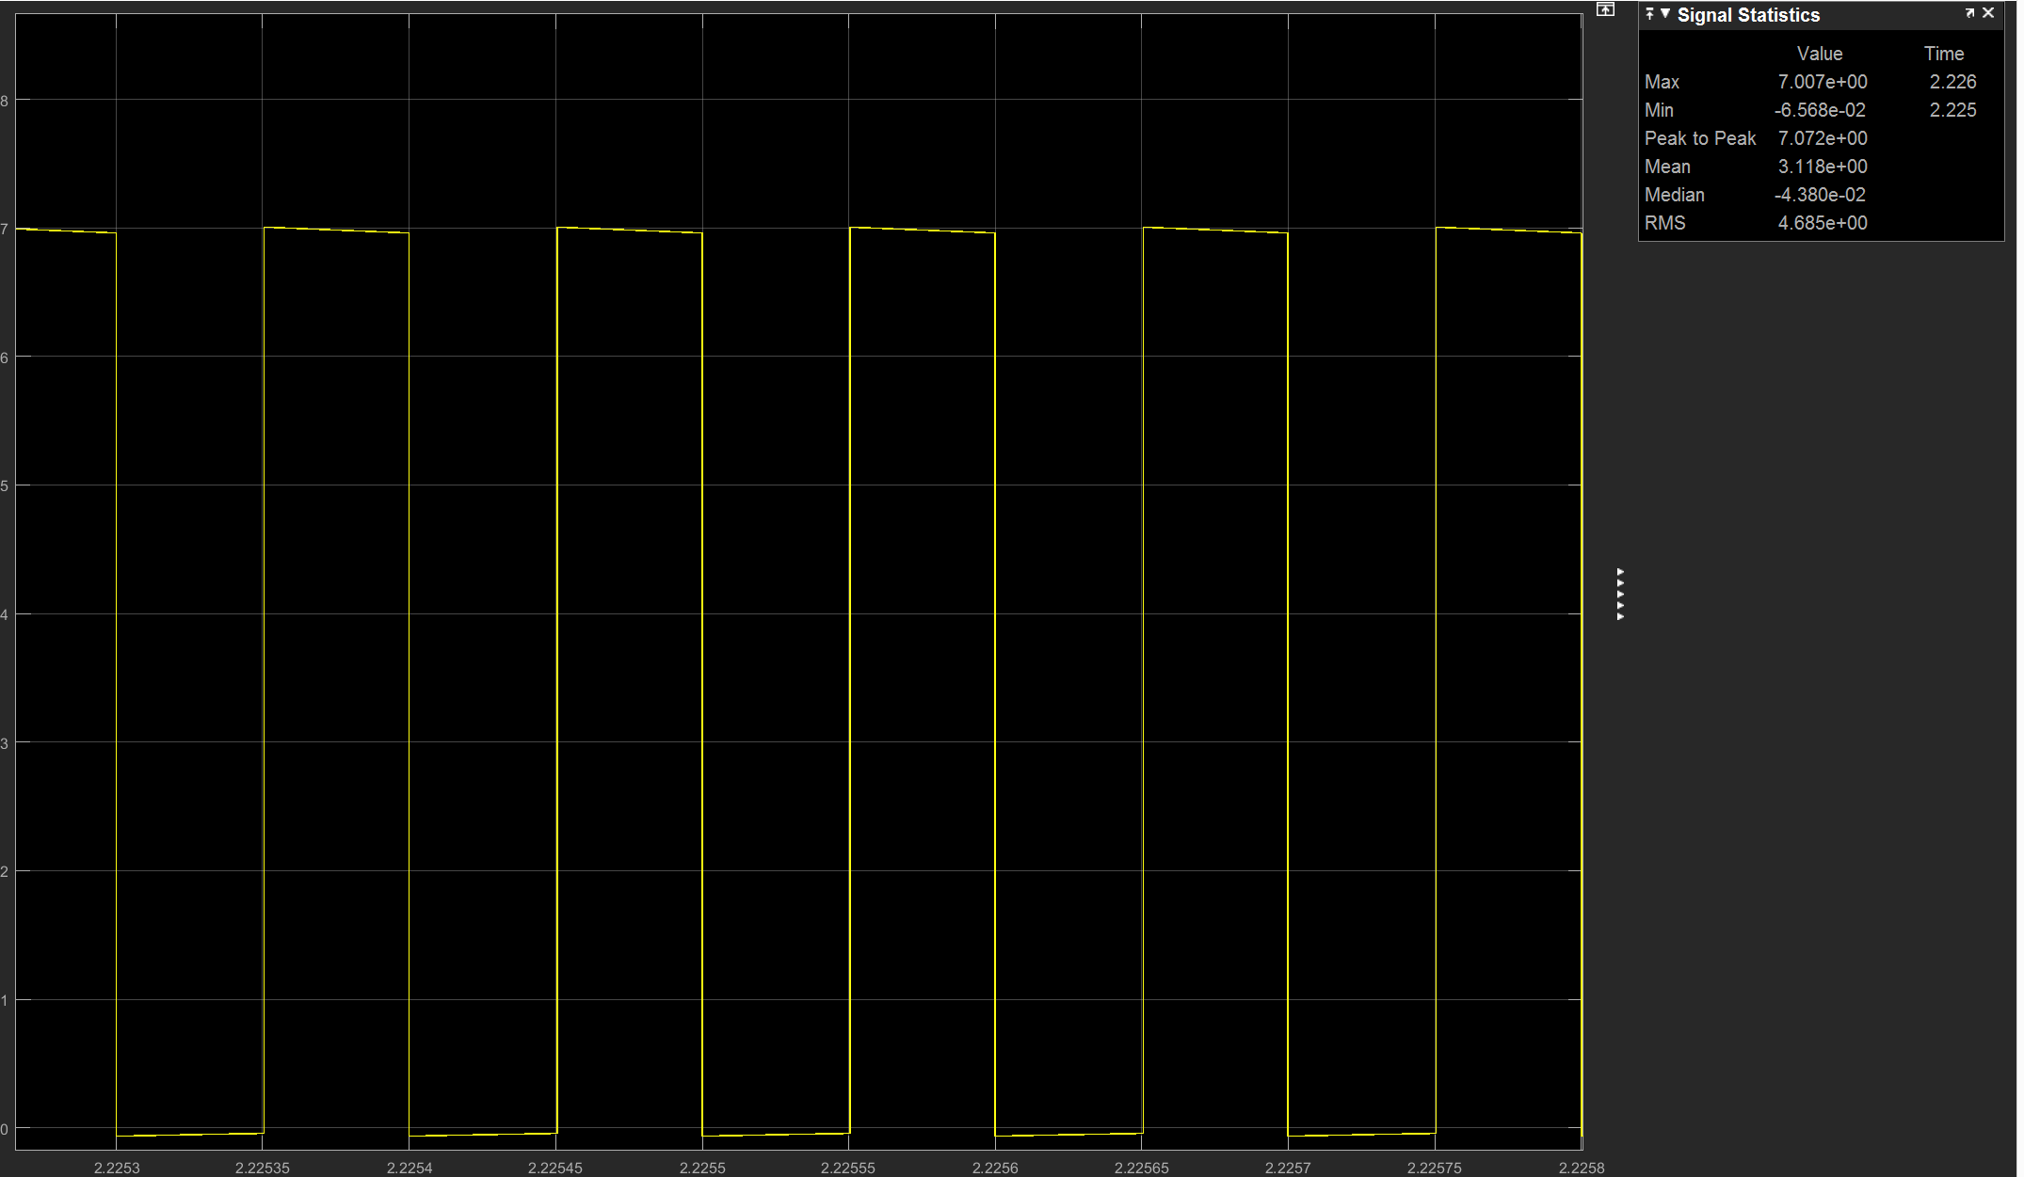

Figure 13 Steady state current of diode

Figure 14 shows MOSFET steady state current.

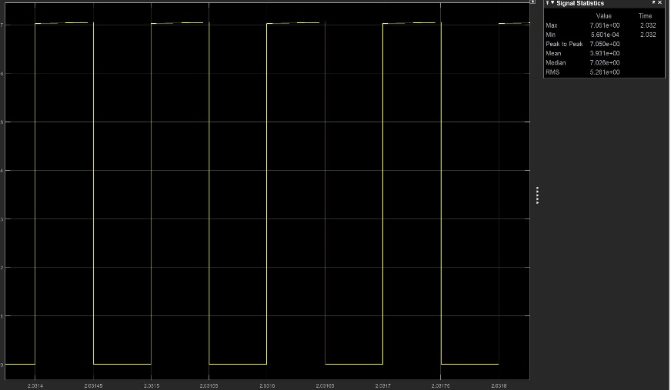

Figure 14 MOSFET steady state current

Figure 15 shows the maximum MOSFET current.

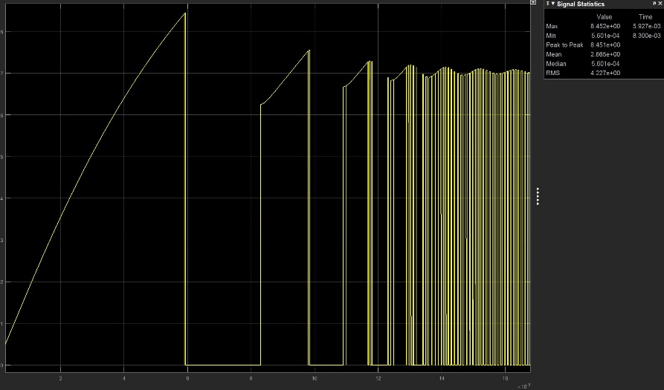

Figure 15 Maximum MOSFET Current

Figure 16 shows the output current ripple.

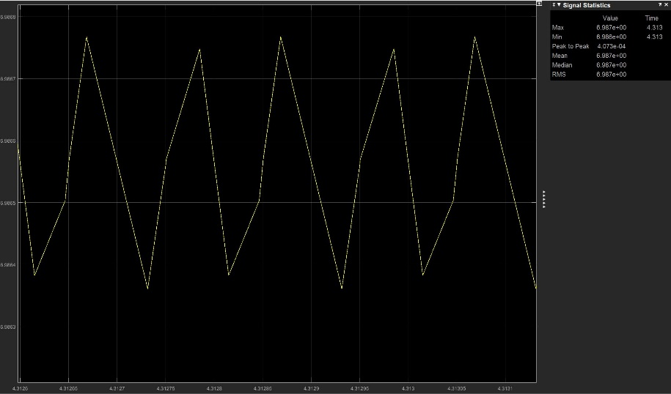

Figure 16 Output current ripple

## Efficiency

The output power is Pout = 28V * 7A = 196W

The power loss on the capacitor is Pcap = Leakage Current*Vcap = 165uA*28V = 4.62mW

The power loss on the inductor is Plossind = Resistance * Current^2 = 46mΩ * 49 = 2.25mW

The power loss on MOSFET is Pmosfet = Duty cycle * Vf * Current = 0.5 * 4V * 7A= 14W

Total Efficiency = 93.33%

## Cost Analysis

The cost analysis is shown in Table 3.

Table 3: Cost Analysis

|  |  |
| --- | --- |
| Component | Price(€) |
| MOSFET | 0,55 |
| Diode | 0,524 |
| Inductor | 21,36 |
| Capacitor | 0,52 |
|  | €22,954 |

## Comments

Due to the fact that the inductance value turned out to be high, the selected inductor costed a lot. Also, 30mH was not a standard inductance value which resulted connecting two inductors in series. Moreover, to decrease the inductor current ripple, inductance may be increased. However, if the inductance gets increased, the corner frequency decreases. The LC low pass filter makes the output current more DC by eliminating the AC components and passing the DC components. The most significant consideration while selecting the components were the current ratings. Also, it is noticed that the price of the components have a proportionality to current ratings.

#### Components

Mosfet: https://www.mouser.com.tr/ProductDetail/ON-Semiconductor/NVD3055L170T4G-VF01?qs=sGAEpiMZZMshyDBzk1%2fWi%2fD7Em5shE8qPMRR%252b7kCcLl4tST46LHPVw%3d%3d

Diode: https://www.mouser.com.tr/ProductDetail/Vishay-Semiconductors/V4PAN50-M3-I?qs=sGAEpiMZZMtQ8nqTKtFS%2fOl9H8JU2QXlVzJElRXOtH7mrYCOvzyDKw%3d%3d

Inductor: https://www.tme.eu/gb/Document/fe3fe9e4b459a56ab43416ac6e63bc69/DTSN33.pdf

Capacitor: <https://www.mouser.com.tr/ProductDetail/Wurth-Electronics/860010675019?qs=sGAEpiMZZMvwFf0viD3Y3aZipiehufnX0L6IjMkoFygxHK8JloZr2g%3d%3d>

# BOOST CONVERTER (Webench)

In this question, a step-up converter i.e. a boost converter is asked to be design as a design engineer of a company. The parameters are given, and the most proper design is asked to be implemented.

After learning the operation principles of Webench, the students have examined several designs in order to learn the design principles and topologies inside out. With the given design parameters, the offered topologies for a selected lapse by means of efficiency, footprint and cost are as follows:

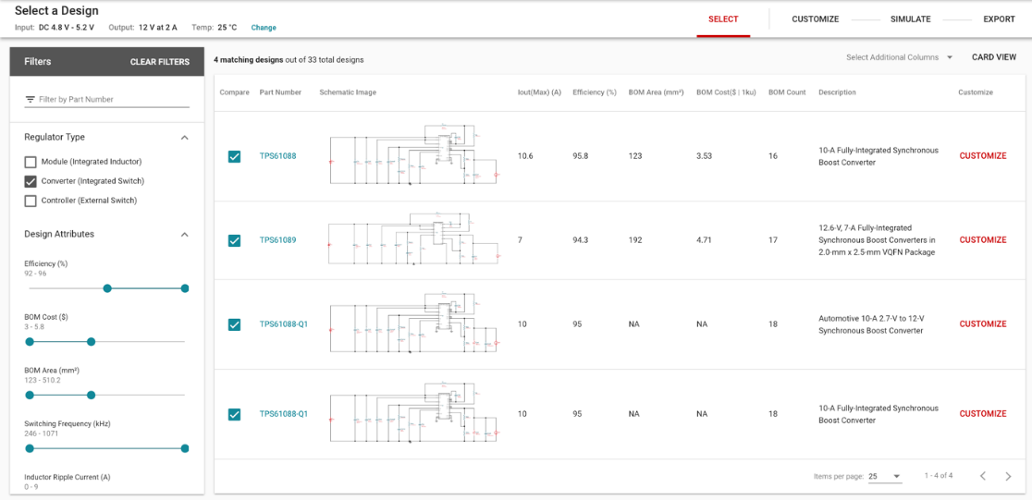

Figure 17 The Designed Topologies for the Boost Converter

After this step, the tools have started in another page and the advanced charting of all the designs are viewed and beside all those designs, the most proper one is selected. The advanced charting of all the designs are as follows:

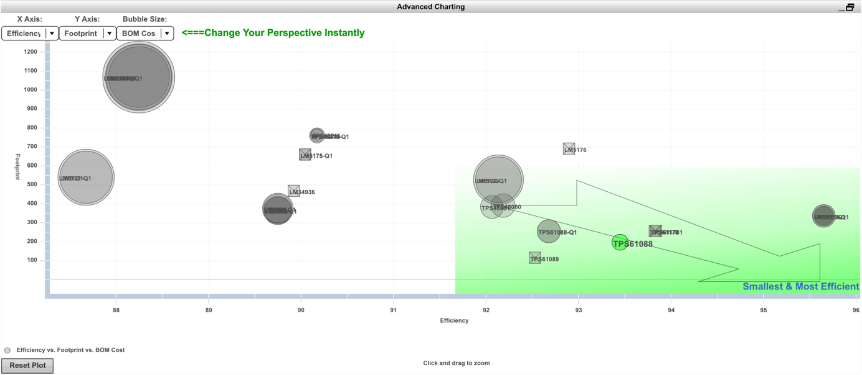

Figure 18 The Advanced Charting of All the Designs

Through those designs, in order to find the most appropriate design thanks to the intercept point of three inputs which are efficiency, cost and footprint. On the very right and bottom hand side of the diagram is the most efficient and less footprint design options are offered. Through all those designs and parameters, TPS61088 is selected because among all designs, it was the most efficient, less footprint and less costed. The design strategy of the students were applying %70 efficiency, %20 cost and %10 footprint affecting the design process of the product. The circuit schematic of the design is given below:

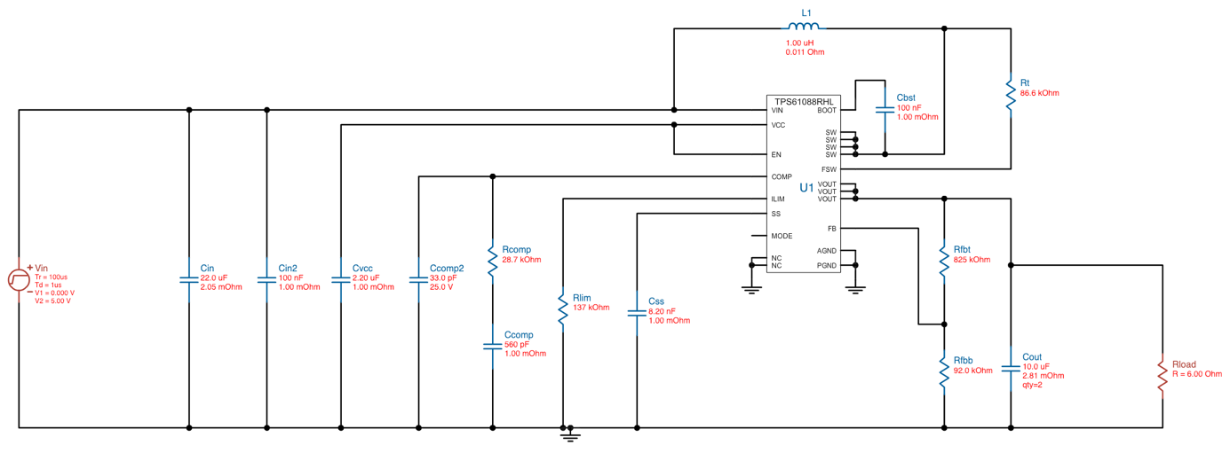

Figure 19 The Final Design of the Boost Converter

This is the boost converter design using some components in order to give the desired output voltage and current at its output stage. The efficiency vs output current graph is illustrated below:

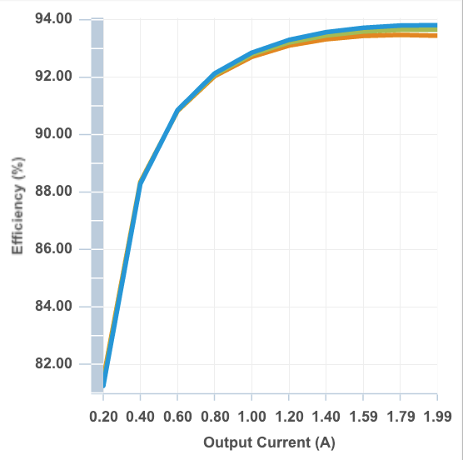

Figure 20 Efficiency vs Output Current of TPS61088 Boost Converter

As one can clearly understand, the efficiency is increasing in accordance with the increasing output current to 2A which is the desired steady state output current. From this graph one can get the result that before the system reaches steady state, the efficiency of this topology is lower, around 80% to 88% compared to the steady state which is 92% to 94%. The output voltage ripple vs output current graph is as follows:

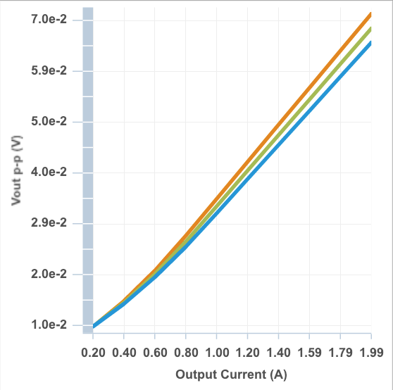

Figure 21 Output Voltage Ripple to Output Current Graph of TPS61088 Boost Converter

As one can understand from the graph, while the output current is increasing under operation, the ripple i.e. the peak-to-peak value of the output voltage is increasing. However, the ripple of the output voltage is 0.07 mV at the steady state which is applicable.

The operation values of the design are tabulated in the table given below:

Table 4: Operation values

|  |  |  |  |  |  |  |
| --- | --- | --- | --- | --- | --- | --- |
|  |  |  |  |  |  |  |
| 2.104A | 0.071V | 93.45% | 78.6 | Boost CCM | 197 | 2.65 $ |

The power loss graph of the circuit elements is given below:

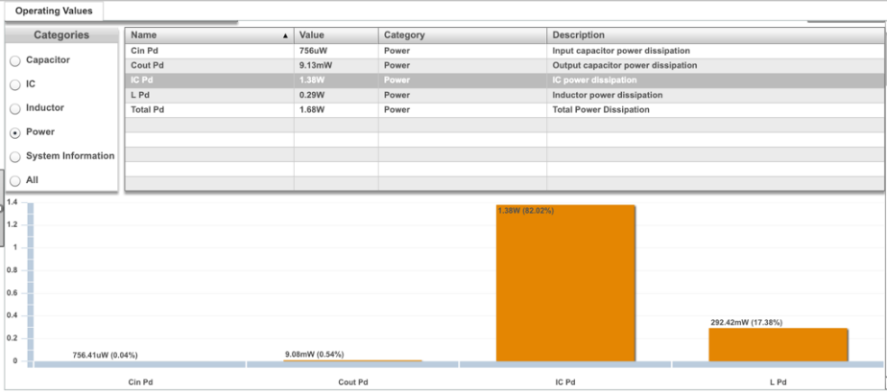

Figure 22 Power Loss Graph of TPS61088 Boost Converter

If one examines the graph, most of the power dissipation is due to integrated circuit used in the boost converter. The power loss in the IC is 1.3W which is accepted to operation process. Besides the IC, the inductor dissipates power’s 292.2mW part. Since the desired power at the output stage is 24W, those values are applicable to the customer’s needs.

The desired simulation results are going to be implemented and discussed.

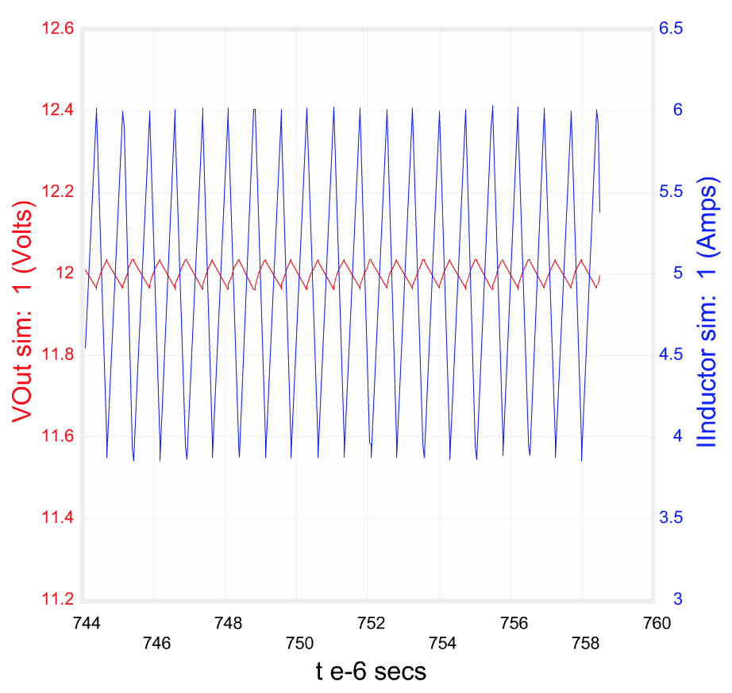

Figure 23 Inductor Current and Output Voltage Graph at the Steady State.

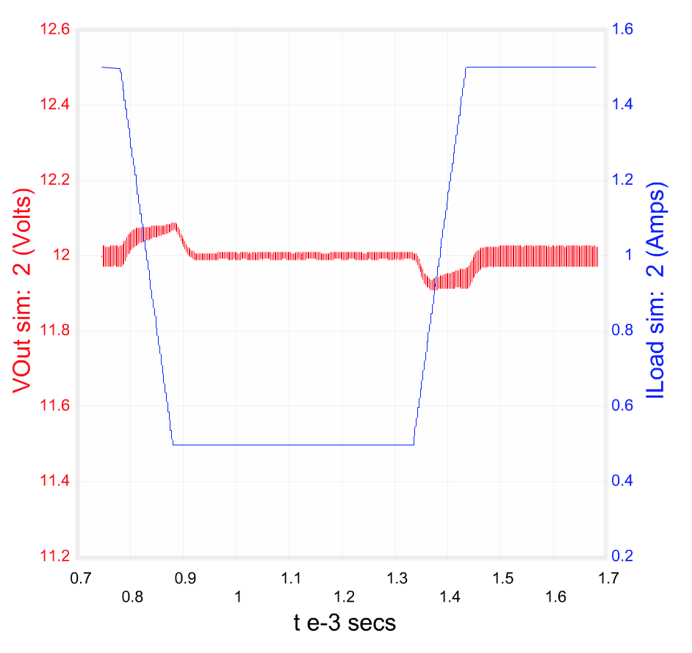

Figure 24: Output Voltage and Load Current vs Time Graph of Load Transient

# CONCLUSION

In this project, first a PM motor is drived with a PI controller and a 3-phase full bridge thyristor. The characteristics of PI controller and its integration with power electronics topologies such as motor drivers were studied and simulated. Then, a buck converter is designed considering given constraints such as current ratings, voltage ratings and cost. Moreover, a PI controller is also implemented on buck converter topology. This showed that it is always better not leave the topology open loop. A feedback is always necessary. Finally, a boost converter is designed on Webench considering the cost, efficiency and footprints. The analyses are made and the circuit is designed.

# REFERENCES

MOUSER. (2013, January 4). Buck Converter Design.

TI. (2015, August 4). Basic Calculation of a Buck Converter's Power Stage.